Chapter 13, Problem 43.

Obtain V₁ and V₂ in the ideal transformer circuit of Fig. 13.108.

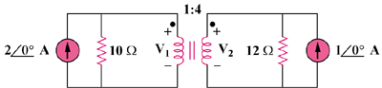

Figure 13.108
For Prob. 13.43.

